2023 Excellence in Healthcare Awards

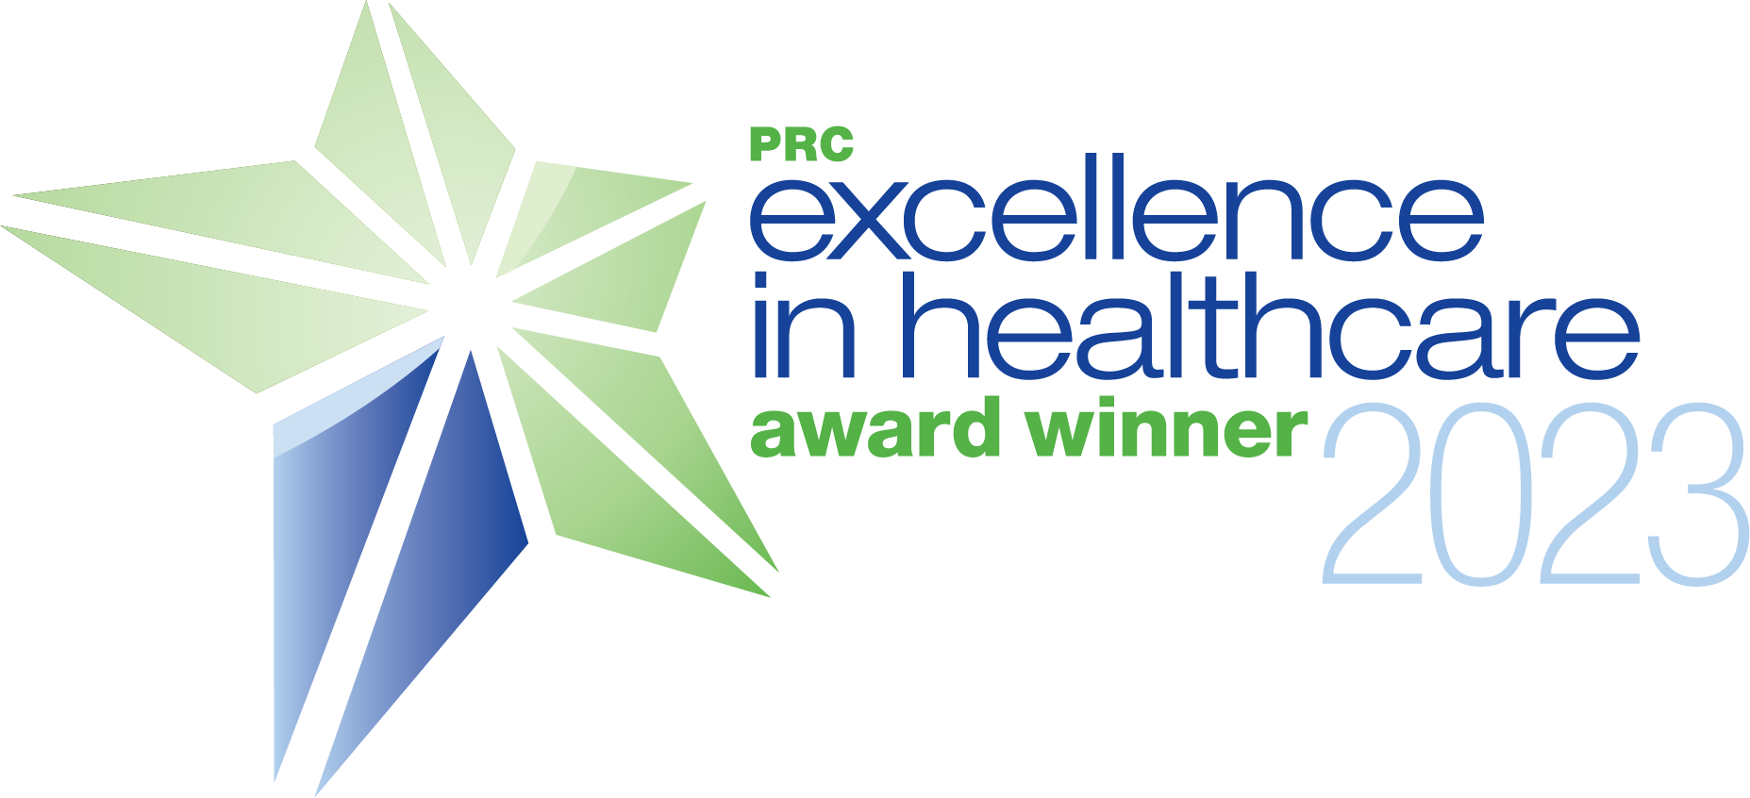

(HOSPITAL NAME) IN (CITY) RECEIVES EXCELLENCE IN HEALTHCARE AWARD

PRC Recognizes Industry’s Best with Annual Awards

City, State (Date) – (Hospital Name) was recently recognized as a (Name of Award: i.e., 4-Star,, Top Performer, Award of Distinction for Excellent Performance) in (Award Type: i.e., inpatient services, outpatient services) for (Study Type: i.e., Physician Engagement, Patient Experience, Employee Engagement) by PRC, a leader in the healthcare intelligence space.

The Excellence in Healthcare Awards recognize organizations and individuals who achieve excellence throughout the year by improving patient experiences, healthcare employee engagement, and/or physician alignment and engagement based on surveys of their (patients, employees, physicians).

“It is an honor to recognize (Hospital Name) with (these/this) Excellence in Healthcare Award(s) for their deserving work,” said Joe M. Inguanzo, Ph.D., President and CEO of PRC. “It takes true dedication and determination to achieve this level of excellence in healthcare and (Hospital Name) has shown their commitment to making their hospital a better place to work, a better place to practice medicine, and a better place for patients to be treated.”

[Optional: Insert quote from Hospital CEO on what being recognized for the award means to them and the community]

and/or

[Optional: Include localized information such as how many people or communities you serve or how long you’ve been in service]

To learn more about the 2022 Excellence in Healthcare Awards, including eligibility and criteria, visit PRCCustomResearch.com.

About PRC
PRC, a leader in the healthcare intelligence space with the most comprehensive healthcare discovery platform, is taking surveys to a new level. PRC’s surveys and intuitive reporting focus on changing the way organizations manage and improve five key areas of the healthcare experience—patient, physician, employee, community, and brand. Over 2,800 healthcare organizations across the United States have used PRC to listen, understand, and take action to create cultures of excellence. To ensure clients have access to leading practices, coaches, and learning resources, PRC is partnered with Healthcare Experience Foundation (HXF) to accelerate paths to excellence. The PRC healthcare discovery platform is a system designed to drive action, optimize engagement, and increase loyalty while building a positive culture across the healthcare ecosystem. www.PRCCustomResearch.com

Media Contacts
Hospital Name
Contact Name, Title
Phone:
Email:

Professional Research Consultants, Inc.
Laurie Speaks
Senior Vice President, Client Success
818-939-4121
LSpeaks@PRCCustomResearch.com

